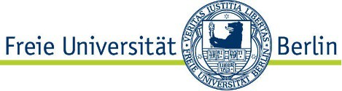

**Information for Applicants**

Abteilung Forschung

Team VI A: Wissens- und Technologietransfer

Kontakt: transfer@forschung.fu-berlin.de

Module: Transfer Coaching

C

The commercial exploitation of research results requires both innovative technology and entrepreneurial expertise in order to be successful on the market. That is why support services in the form of workshops and/or individual coaching sessions are a core component of the TRANSFER funding initiative. The range of topics covered is as diverse as the projects themselves, spanning from business model development to specialized patent knowledge to soft skills for entrepreneurs.

The workshops and coaching sessions promote the personal development of participants and provide them with expertise on entrepreneurship and the market. Funding recipients can also expand their network and establish contacts for potential cooperation projects and/or spin-offs. Coaching sessions amounting to six hours in total are recommended.

A selection of coaches are available to view by category here: <https://www.science-startups.berlin/coaches/>. The VI A team can help you if you have any special requirements.

Please state in your TRANSFER application which support services you require and how the workshop and/or individual coaching would contribute to the future commercial exploitation of your idea.